**Adding a New Product in the Database**

**Output:**

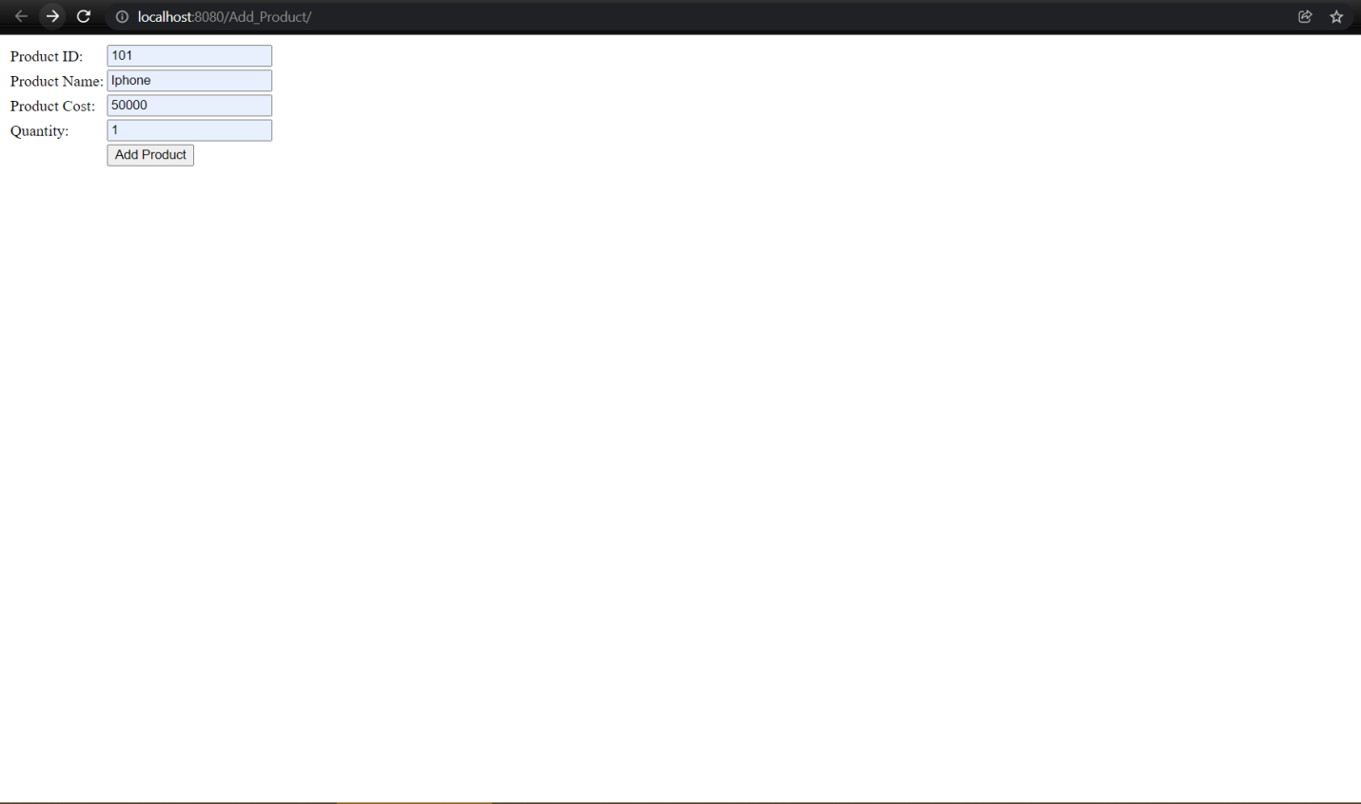

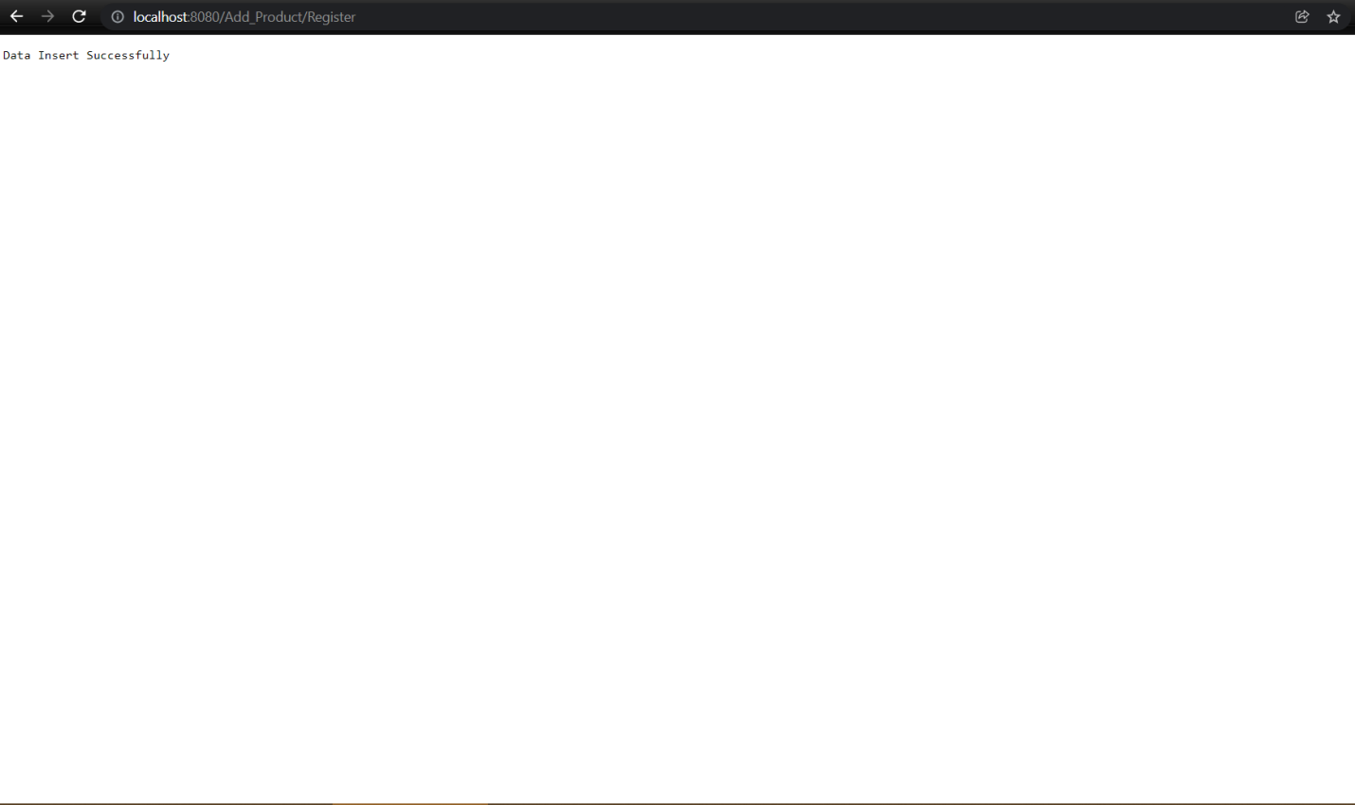

**Product add in database:**

